HBXL PLANS SERVICE ORDER FORM

Your Details (type your details in the boxes below):

NAME: |  | COMPANY NAME:
ADDRESS:  INC POSTCODE: |  | SITE ADDRESS:
TELEPHONE NUMBER: |  | MOBILE NUMBER:
EMAIL ADDRESS:
CLIENT NAME: |  | CLIENT ADDRESS:
CLIENT TELEPHONE NUMBER: |  | PLEASE CONFIRM YOU ARE HAPPY FOR HBXL PLANS SERVICE TO CONTACT CLIENT DIRECT: | YES | NO

Your Order: Indicate the level of HBXL Plans Service you require (put an X in the appropriate box and enter the fee using the table below):

MARK WITH X | SERVICE LEVEL REQUIRED | FEE (SEE TABLE BELOW)
 | SCHEME DRAWINGS ONLY | £
 | DRAWINGS FOR PLANNING PERMISSION SUBMISSION* | £
 | DRAWINGS FOR PLANNING & BUILDING REGULATIONS* | £

*HBXL Plans Service does not provide structural calculations. Should your plans require structural calculations, we will require you to instruct a Structural Engineer and provide us with the appropriate calculations prior to submission of your plans.

Table of Rates for HBXL Plans Service
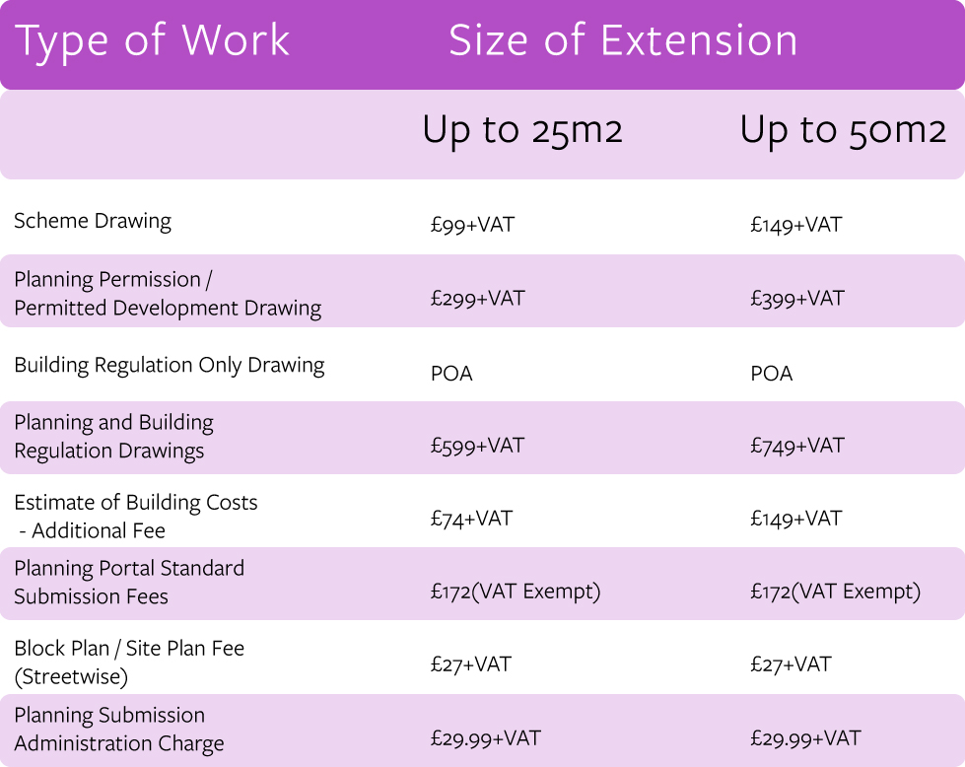
Additional charges:

If you would like us to submit your plans for Planning Permission/Permitted Development or Building Regulations, you will be required to pay the submission fees levied by the Local Authority and/or Building Control Inspector in addition to our fees above plus any applicable charge for obtaining Ordinance Survey Site Plan and Location Plans. We will confirm these charges with you before we take payment.

For larger projects please get in touch with us to discuss on 0117 9167894 or using plans@hbxl.co.uk.

Indicate the format you require (put an X in the appropriate box):

MARK WITH X | FORMAT OF DRAWINGS
 | I WOULD LIKE THE PLANS EMAILED TO ME IN PDF FORMAT AT NO EXTRA CHARGE TO THE AGREED FEE.
 | I WOULD LIKE AN A3 COPY OF THE PLANS POSTED TO ME AT AN EXTRA CHARGE OF £14.99 + VAT IN ADDITION TO THE AGREED FEE.

Plans Submission:

(Only applicable if you have selected Planning Permission or Planning & Building Regs Service Level above. Put an X in the appropriate box if you do not want us to submit your plans on your behalf.):

MARK WITH X | SUBMISSION OPTIONS
PUT AN X IN THE BOX IF YOU DO NOT WANT THE DRAWINGS SUBMITTED ON YOUR BEHALF TO YOUR LOCAL AUTHORITY PLANNING DEPARTMENT.
(Otherwise we will undertake the submission of your plans to your local council as standard. You are responsible for the normal council planning application fees).
 | PUT AN X IN THE BOX IF YOU DO NOT WANT THE DRAWINGS SUBMITTED ON YOUR BEHALF TO BUILDING CONTROL. (Otherwise we will undertake the submission of your plans to building control as standard. We do not charge extra for this service but please be aware you will remain responsible for the normal inspection fees).

Acting as your agent: (If you have selected Drawings for Planning Permission or Planning/Building Regs above, please put an X in the box below):

MARK WITH X
I GIVE PERMISSION FOR HBXL PLANS SERVICE TO ACT AS MY AGENT FOR THE PROJECT DESCRIBED ON THIS ORDER FORM WHEN SPEAKING TO THE LOCAL AUTHORITY PLANNING DEPARTMENT, BUILDING INSPECTOR AND/OR ANY OTHER RELEVANT PARTIES.

Terms and Conditions: (Put an X in the appropriate box and sign or type your name below)

I ACCEPT THE TERMS AND CONDITIONS OF THE DESIGN SERVICE (PLEASE SEE TERMS AND CONDITIONS ATTACHED)
CUSTOMER SIGNATURE:
(PLEASE TYPE OR SIGN)

Description of the Building Project:

DO YOU WISH TO BASE YOUR EXTENSION ON ONE OF THE DESIGNS FROM THE PLANS SERVICE DESIGN PORTFOLIO? | Yes | No

IF YES, WHICH DESIGN HAVE YOU SELECTED?

PLEASE DESCRIBE BELOW ANY MODIFICATIONS YOU WISH TO MAKE TO THE DESIGN YOU HAVE SELECTED:

Please provide us with as much additional information as possible about the project.
e.g. What is the reason for the extension? What are the priorities for the project? Are there any similar extensions in the area? Do you envisage there being any constraints or problems with the design? Are there any additional requests for the design or special materials to be used?

Photographs:

Please provide us with as many photographs of the existing site as possible including internal and external views. (Put an X in the box below to confirm that you have attached photographs).

I CONFIRM THAT I HAVE ATTACHED PHOTOGRAPHS OF THE EXISTING SITE.

Survey Sheet:

Please complete the attached Survey Sheet with a sketch of the building project.

Fill in your name and the number of pages you are sketching.

Sketch out the walls of the property.

Add dimensions of walls, windows, chimney breasts and doors in mm.

Mark any staircases with an arrow.

Clearly indicate the following items where applicable:

- Sanitary ware | - Kitchen sink | - Types / dims of doors
- Types / dims of windows | - Radiators | - Boiler
- Flues | - Electric / Gas meters | - Air vents
- Drainage gullies | - Internal soil pipes | - External soil pipes
- Rainwater pipes | - Soakaways | - Depth/location of manholes
- Depth/location shallow access chambers | - Rodding eyes | - Services inc. gas, electricity & water

Project Checklist:

Complete the following checklist about your project. Provide as much information as you can as this will help the Plans Service team to draw as accurate and detailed plan as possible.

PRE-CONSTRUCTION INFORMATION REQUIRED BY DESIGNER | MARK WITH AN X OR ENTER REQUIRED INFORMATION INTO THE FIELDS BELOW
ARE YOU THE PRINCIPLE CONTRACTOR? | YES | NO
IF YOU ANSWERED NO TO THE QUESTION ABOVE, PLEASE PROVIDE NAME, ADDRESS AND TELEPHONE NUMBER OF THE PRINCIPLE CONTRACTOR
ARE YOU THE PRINCIPLE DESIGNER? | YES | NO
IF YOU ANSWERED NO TO THE QUESTION ABOVE, PLEASE PROVIDE NAME, ADDRESS AND TELEPHONE NUMBER OF THE PRINCIPLE DESIGNER
PROJECT START DATE
EXPECTED PROJECT DURATION
WILL THE PROJECT AFFECT NEIGHBOURS’ PROPERTY? E.G. TREES, LANDSCAPING, CABLES, SERVICES, BOUNDARY FENCES/WALLS, OTHER | YES | NO
 | IF YES, PLEASE GIVE DETAILS
ARE THERE ANY EXISTING PLANS OR DRAWINGS? | YES  IF YES, PLEASE SUPPLY THEM | NO
HAVE YOU INDICATED OVERHEAD CABLES ON THE SURVEY SHEET? | YES | NO OVERHEAD  CABLES
ARE THERE ANY HIGH VOLTAGE POWERLINES CLOSE TO THE SITE? | YES | NO
ARE THERE ANY WATER COURSES CLOSE TO THE SITE? | YES | NO
IS THERE ANY DEMOLITION INVOLVED IN THE PROJECT? | YES | NO
IS THERE ANY OTHER ASPECT OF THIS PROJECT INVOLVING ANY OTHER PARTICULAR SPECIFIC RISKS? | YES | NO
 | IF YES, PLEASE GIVE DETAILS

EXTENSION CONSTRUCTION INFORMATION: | MARK WITH AN X OR ENTER REQUIRED INFORMATION INTO THE FIELDS BELOW:
WALL CONSTRUCTION | BRICK & BLOCK | BLOCK & BLOCK
 | TIMBER FRAME | TIMBER FRAME & BLOCK
 | TIMBER FRAME & BRICK | OTHER (PLEASE SPECIFY)
WINDOWS | PVC-U | SOFTWOOD
 | HARDWOOD | ALUMINIUM
 | NOT APPLICABLE
ACCESS DOORS | PVC-U | SOFTWOOD
 | HARDWOOD | ALUMINIUM
 | NOT APPLICABLE
PATIO DOORS | PVC-U | SOFTWOOD
 | HARDWOOD | ALUMINIUM
 | NOT APPLICABLE
BI-FOLDS | PVC-U | HARDWOOD
 | ALUMINIUM | NOT APPLICABLE
ROOF TILE TYPE IF KNOWN (EXTENSION)
BRICK TYPE IF KNOWN (EXTENSION)
BRICK PRICE IF KNOWN (PER BRICK) | PENCE

EXISTING BUILDING INFORMATION: | MARK WITH AN X OR ENTER REQUIRED INFORMATION INTO THE FIELDS BELOW
EXTERNAL WALL CONSTRUCTION | SOLID |  |  | CAVITY
CAVITIES INSULATED? | YES |  |  | NO
OVERALL WALL THICKNESS | ___ _____ MM
FOUNDATION DEPTH (OTHERWISE WE WILL ASSUME STANDARD 1000MM DEEP 600MM WIDE) | ___ ______ MM
INTERNAL WALLS DOWNSTAIRS (PLEASE INDICATE ON SKETCH IF DIFFERENT IN DIFFERENT ROOMS) | BLOCK | STUD |  |  | OTHER
INTERNAL WALLS UPSTAIRS (PLEASE INDICATE ON SKETCH IF DIFFERENT IN DIFFERENT ROOMS) | BLOCK | STUD |  |  | OTHER
STANDARD STRIP FOUNDATIONS | YES |  | NO
IF YOU ANSWERED NO TO THE QUESTION ABOVE, PLEASE GIVE FURTHER DETAILS ABOUT EXISTING FOUNDATIONS | PILES |  | RAFT
 | TRENCH FILL |  | OTHER (PLEASE GIVE DETAILS):
EXISTING GROUND FLOOR CONSTRUCTION
EXISTING FIRST FLOOR CONSTRUCTION
EXISTING ROOF CONSTRUCTION | CUT TIMBER |  |  | TRUSS ROOF
EXISTING BRICK TYPE IF KNOWN
EXISTING ROOF TILE TYPE IF KNOWN
HAS THE EXISTING PROPERTY BEEN EXTENDED SINCE DATE OF ORIGINAL CONSTRUCTION? | YES  PLEASE INDICATE ON SKETCH SHEET AND PROVIDE FURTHER DETAILS BELOW: |  | NO
ARE THERE ANY MASONRY OR LARGER OUTBUILDINGS ON THE SITE E.G. LARGE SHED ETC.? | YES |  | NO
ARE THERE ANY EASEMENTS ON THE SITE FOR ACCESS? | YES |  | NO
ARE THERE ANY EASEMENTS FOR MAINS DRAINS? | YES |  | NO
ARE THERE ANY EASEMENTS FOR MAINS GAS? | YES |  | NO
ARE THERE ANY EASEMENTS FOR MAINS ELECTRICITY? | YES |  | NO
ARE THERE ANY EASEMENTS FOR TELECOMS? | YES |  | NO
IS THE EXISTING PROPERTY IN AN AREA OF OUTSTANDING NATURAL BEAUTY? | YES |  | NO
IS THE EXISTING PROPERTY IN CONSERVATION AREA? | YES |  | NO
IS THE EXISTING PROPERTY WITHIN A SITE OF SPECIAL SCIENTIFIC INTEREST? | YES |  | NO
ARE THERE ANY OTHER COVENANTS THAT WOULD PREVENT AN EXTENSION BEING BUILT TO THE EXISTING PROPERTY? | YES |  | NO
ARE THERE ANY OTHER REASONS WHY AN EXTENSION CANNOT BE BUILT? | YES |  | NO
 | IF YES, PLEASE GIVE DETAILS
ARE RADON BARRIERS REQUIRED AT THE LOCATION OF THE PROJECT? | YES |  | NO
WHAT IS THE HEIGHT OF THE WATER TABLE? | MM
IS THE EXISTING PROPERTY BUILT ON SHRINKABLE CLAY OR SAND? | YES |  | NO

Thank you for completing this form. Please send via email to:

plans@hbxl.co.uk

HBXL Plans Service: Terms and Conditions
House Builder XL Limited (“HBXL”) agrees to provide the services (the “Services”) requested in the HBXL Plans Service Order Form (the “Order Form”) and confirmed in the HBXL Plans Service Confirmation Email (the “Confirmation Email”) subject to the following terms and conditions. You should carefully read this document as it contains the terms and conditions applicable to the provision of the Services and includes limitations of HBXL’s liability to you and others.
The Services
- HBXL warrants that it will carry out the Services:
  - using the reasonable care and skill to be expected of an ordinary, competent building contractor. You acknowledge that HBXL is not an architect or similarly qualified designer (and nor are its employees, agents and subcontractors) and does not hold itself out as such;
  - if stated in the Confirmation Email, so that the designs, drawings, plans and other documents (the “Deliverables”), when completed, are suitable for submission for planning and/or building regulations approval (but HBXL does not warrant that such approvals will be granted by the relevant statutory authorities);
  - using reasonable endeavours to provide the Services within any agreed time, but time shall not be of the essence in relation to the supply of the Services; and
  - in compliance with its obligations (if any) as a designer under the Construction (Design and Management) Regulations 2015 (or any re-enactment thereof) but, for the avoidance of doubt, you acknowledge that HBXL shall not be the “principal designer” for the purpose of those Regulations whether by carrying out the Services or otherwise.
- In carrying out the Services HBXL shall be entitled to rely upon all documents, measurements, drawings, plans and all other information provided by you (together, the “client-supplied information”) without any further checks, investigation or analysis and you warrant that all client-supplied information is true, accurate, up-to-date and free from discrepancies.
- If HBXL agrees, as part of the Services, to submit the Deliverables to any statutory authority (such as planning or building control) on your behalf, HBXL will pay the statutory fees, charges or other sums levied by such authorities for the submissions. If not itemised as part of HBXL’s fees, you will reimburse HBXL for such fees, charges or other sums within 7 days of a written request from HBXL.
- Subject to any rights in the client-supplied information, the copyright in the Deliverables shall remain vested in HBXL.
- Subject to payment of all of HBXL’s fees for the Services that are due and payable under this contract, HBXL will grant you an irrevocable, non-exclusive licence to use, copy and modify the Deliverables (including reproducing the designs contained in them) for all purposes in connection with the construction work contemplated therein, including:
  - submission to the planning and/or building control authorities;
  - further developing the Deliverables so that they are suitable for issue for construction of the works; and/or
  - the construction, sale, letting and/or repair of the works,
but HBXL shall not be liable for any use of the Deliverables (or the designs contained in them) if they have been modified or are used for any purpose other than that for which they were provided.
Limitations of liability
- Subject to clause 7, HBXL shall have no liability to you arising out of or in connection with the provision of the Services and the Deliverables (whether in contract, tort (including negligence), breach of statutory duty or otherwise):
  - for any loss of profit, loss of business, loss of rent or any other indirect or consequential loss; and
  - in respect of all other losses, in excess of £1,000,000 in aggregate for all claims.
- Nothing in this contract shall limit or exclude HBXL’s liability for losses arising out of:
  - death or personal injury caused by the negligence of HBXL (or its employees, agents or subcontractors); or
  - fraud or fraudulent misrepresentation.
Termination and force majeure
- You may terminate this contract by giving not less than 14 days’ written notice to HBXL. In the event of termination of this contract before the Services have been completed:
  - you shall be liable to pay HBXL for the time spent carrying out the Services up to the date of termination at the hourly rate as published in the HBXL Plans Service Price List (please see www.plans-service.co.uk) as of the date of termination; and
  - following payment of our fees calculated on the basis set out at clause 8(a), HBXL will provide to you the Deliverables in whatever form they have reached as of time when the contract was terminated.
- For the purposes of this contract “Force Majeure Event” means an event beyond the reasonable control of HBXL including but not limited to strikes, lock-outs or other industrial disputes (whether involving the workforce of HBXL or any other party), failure of a utility service or transport network, act of God, war, riot, civil commotion, malicious damage, compliance with any law or governmental order, rule, regulation or direction, accident, breakdown of plant or machinery, fire, flood, storm or default of suppliers or subcontractors.
- HBXL shall have no liability for any losses caused or contributed to by any delay or failure to perform its obligations under this contract as a result of a Force Majeure Event.
- If one or more Force Majeure Events prevents HBXL from providing any of the Services for more than 3 consecutive weeks, either party shall, without limiting its other rights or remedies, have the right to terminate this contract immediately by giving written notice to the other.
Payment
- You agree to pay HBXL the full fee set out in the Confirmation Email for the Services before any work starts.
Variations to the Services
- If you wish to change your requirements in respect of the Services, or to have us perform further work following completion of the Services, and HBXL (in its absolute discretion) agrees to carry out such changed or additional work, you will be charged over and above our original agreed fee using the hourly rate as published in the HBXL Plans Service Price List (please see www.plans-service.co.uk) as of the date of such agreement for that changed or additional work.
- HBXL will confirm the additional fee in writing before carrying out the additional or changed work. You agree to pay HBXL the additional fee in full before any further work is carried out by HBXL.
Assignment and subcontracting
- HBXL may at any time assign, transfer, charge, subcontract or deal in any other manner with all or any of its rights under this contract and may subcontract or delegate in any manner any or all of its obligations under this contract to any third party or agent.
- You may not assign, transfer, charge, subcontract or deal in any other manner with all or any of its rights or obligations under this contract without the written prior written consent of HBXL.
Notices
- Any notice or other communication required to be given to a party under or in connection with this contract shall be in writing (which may include email).
- Notices or communications not sent by email shall be delivered to the other party personally or sent by prepaid first-class post, recorded delivery or by commercial courier, at its registered office (if a company) or (in any other case) its principal place of business, or sent by fax to the other party's main fax number.
- Any notice or other communication shall be deemed to have been duly received if delivered personally, when left at the address referred to above or, if sent by pre-paid first-class post or recorded delivery, at 9.00am on the second business day after posting, or if delivered by commercial courier, on the date and at the time that the courier’s delivery receipt is signed, or if sent by fax, on the next business day after transmission. Notices or communications sent by email shall be deemed to have been duly received at the actual time of delivery to the recipient’s mail server.
- Clauses 17 to 19 shall not apply to the service of any proceedings or other documents in any legal action.
Waiver
- A waiver of any right under this contract is only effective if it is in writing and shall not be deemed to be a waiver of any subsequent breach or default. No failure or delay by a party in exercising any right or remedy under the contract or by law shall constitute a waiver of that or any right or remedy, nor preclude or restrict its further exercise. No single or partial exercise of such right or remedy shall preclude or restrict the further exercise of that or any other right or remedy.
Severance
- If a court or any other competent authority finds that any provision of this contract (or part of any provision) is invalid, illegal or unenforceable, that provision or part-provision shall, to the extent required, be deemed deleted, and the validity and enforceability of the other provisions of this contract shall not be affected.
- If any invalid, unenforceable or illegal provision of this contract would be valid, enforceable and legal if some part of it were deleted, the provision shall apply with the minimum modification necessary to make it legal, valid and enforceable.
No partnership
- Nothing in the contract is intended to, or shall be deemed to, constitute a partnership or joint venture of any kind between any of the parties, nor constitute any party the agent of another party for any purpose. No party shall have authority to act as agent for, or to bind, the other party in any way.
Third parties
- A person who is not a party to the contract shall not have any rights under or in connection with it (unless such a person has taken an assignment in accordance with clause 15 and/or 16).
Variations to the contract
- Except as set out in these conditions, any variation, including the introduction of any additional terms and conditions, to this contract, shall only be binding when agreed in writing and signed on behalf of HBXL.
Disputes
- This contract, and any dispute or claim arising out of or in connection with it or its subject matter or formation (including non-contractual disputes or claims), shall be governed by, and construed in accordance with, English law, and the parties irrevocably submit to the exclusive jurisdiction of the courts of England and Wales.
Entire agreement
- These terms and conditions, the Confirmation Email and the Order Form are the entire agreement between you and HBXL in relation to the Services and supersedes any previous agreement or understanding between the parties. Save as expressly provided for in this contract, each party agrees that it has not relied upon any representation made by or on its behalf prior to entering into this contract. All other warranties, terms and conditions, whether express or implied by statute or otherwise, are excluded to the fullest extent permitted by law.
- These terms and conditions, the Confirmation Email and the Order Form are to be read together. In the event of any conflict between them, they shall be read in the following order of precedence:
  - the Confirmation Email shall take precedence over the other documents; then
  - these terms and conditions; and finally
  - the Order Form.

